**Z-test for One Sample**

Procedure:

1. State the claim mathematically and verbally. Identify the null and alternative hypotheses.

2. Specify the level of significance.

3. Sketch the sampling distribution.

4. Determine the critical value(s).

5. Determine the rejection regions(s).

6. Find the standardized test statistic.

7. Make a decision to reject or fail to reject the null hypothesis.

8. Interpret the decision in the context of the original claim.

Sample Data (Matches):

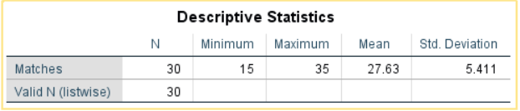

Population Data (Matches):

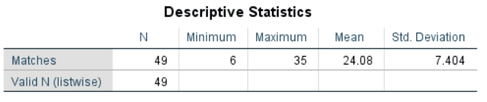

Z-test (1 Sample)

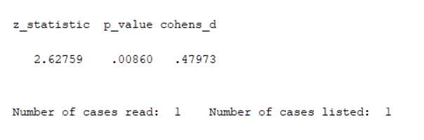

Ho: Sample mean population (Matches played by top 30 batsman) is equal to the Population mean population (Matches played by all 49 Batsman)

H1: Matches played is different

At Alpha = 0.05, for p<0.5, reject Ho.

Therefore, Null Hypothesis is rejected (as p = 0.008 <0.5) and Matches by Top 30 batsman is not same as Matches played by all the batsman in Population (i.e. 49)